Representing the spread of the tweet sorted by country in this format:

<https://observablehq.com/@d3/hierarchical-bar-chart>

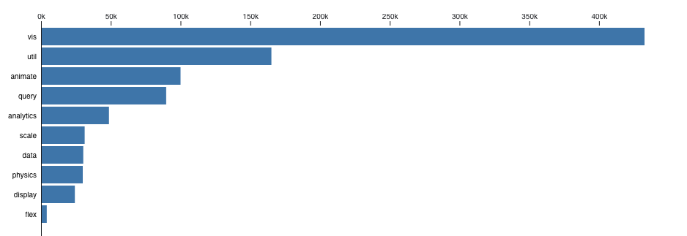

Represent the percentage of tweets, retweets and replies (Maybe likes).

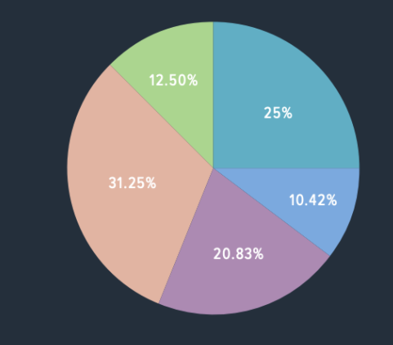

Represent where the tweet has been created at with dots on the map:

